Testing and evaluation of the system
Testplan
Test no. | Test name | Expected result | Actual result | Success/failure | proof | comment
1 | Help screen works | yes | yes | success | Screenshot 1
2 | Go to q1 when start is pressed | Displaying q1 | Displaying q1 | success | Screenshot2
3 | Next button works | Displaying q2 | Displaying q2 | success | Screenshot 3
4 | Correct box coloured | textbox2 is blue | textbox2 is blue | success | Screenshot 3
5 | Previous button works | Displaying q1 | Displaying q1 | success | Screenshot 2
6 | Exit button works | Program closes | Program closes | success | Screenshot 4
7 | Flag button works | Q2 flagged | Q2 flagged | success | Screenshot 5 | Shown by orange box
8 | View flagged works | Flagged list shows q2 | Flagged list shows q2 | success | Screenshot 6
9 | Next flagged works | Goes from q1 to q2 | Goes from q1 to q2 | success | Screenshot 1 and 5
10 | Can't finish with flags | Message box asking to un flag | Message box asking to un flag | success | Screenshot 7
11 | unflagging button works | Q2 not flagged | Q2 not flagged | success | Screenshot 3 | Box is blue again
12 | Finish button gets correct score | 10%/1/10 | 10%/1/10 | success | Screenshot 8 | Chose 1/10 as score to test
13 | Boxes colour correctly for score | Q1 green, all others red | Q1 green, all others red | success | Screenshot 8 | Box 1 is green, rest red
14 | Retake test button works | Application restarts | Application restarted | success | Screenshot 9
15 | Try again for bellow 60% | Try again message | Try again message | success | Screenshot 8
16 | Between 6 and 8 message | Message for between 6 and 8 | Message for between 6 and 8 | success | Screenshot 10
17 | Well done for over 80% | Well done message | Well done message | success | Screenshot 11
18 | Back button works | Results screen hidden | Results screen hidden | success | Screenshot 12 | The boxes are red/green
19 | Score stays the same on 2nd try | Stays at 10% | Stays at 10% | success | Screenshot 8
20 | Correct list works | Shows q1 | Shows q1 | success | Screenshot 13
21 | Incorrect list works | Shows all question but q1 | Shows all question but q1 | success | Screenshot 13

Evaluation.
The purpose of the assignment was to create a quiz application that met the requirements described in the assignment brief .
The application that was produced did a good job of meeting the required criteria, it met major points like providing 10 questions about a relevant theme and calculating scores, but it also included more minor ones such as buttons to show lists of correct and incorrect answers,one feature that doesn't function is the message warning users that they haven't answered or flagged a question, this was implemented but was left non-functional since it caused a few minor problems and made the program more annoying to use.

The 10 questions provided by the application where focused on the theme and can all be answered or flagged as required,after flagging any question the flag system allows the user to see a list of flagged questions, go to the next flagged question or un flag it, the system will also stop the user from finishing whilst they have flagged questions, which helps make sure users answer all the questions and helps the quiz meet it's requirements.

Once the questions have been answered the application then calculates and shows the user's score out of 10, to further meet the requirements it also allows the user to click a button to see a list of correct or incorrect answers (initially it automatically showed them but I changed this to better fit the requirements) as well as go back to retry the questions, however it keeps there score locked at the original value unless they press the retake test button, which restarts the application.

The application is also fairly straightforward and simple to use, even if some of the questions had obscure or difficult answers. All in all I think the program was fairly good since it is simple to use and meets most of it's requirements, including all the most important ones and many others besides.

Proof screenshots.
Screenshot 1
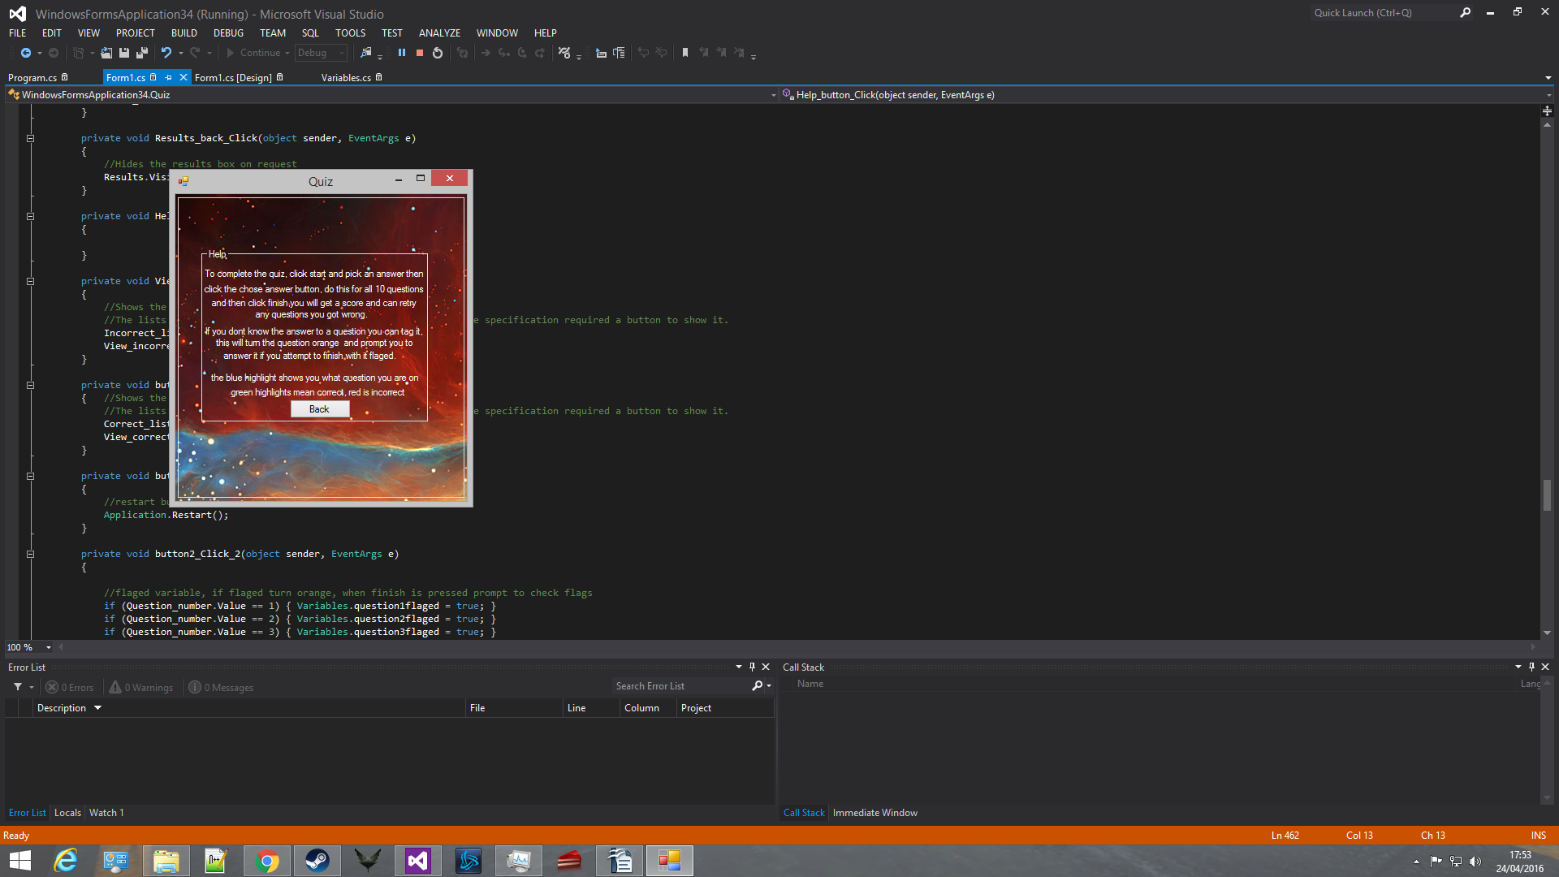

Screenshot 2
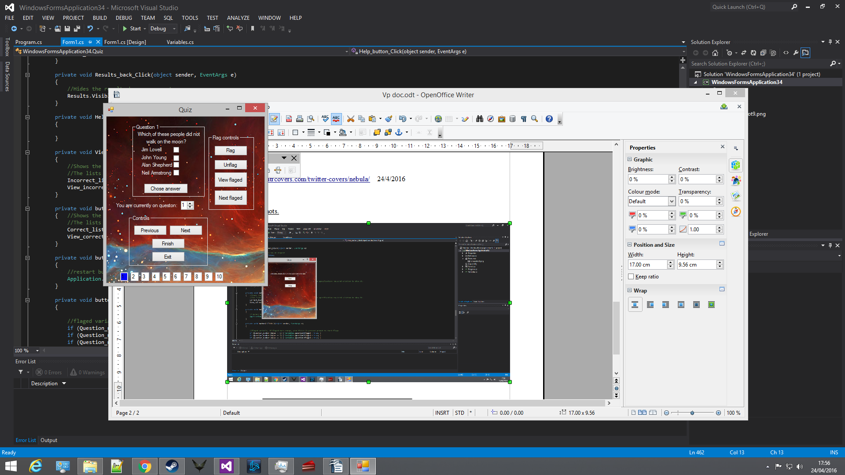

Screenshot 3
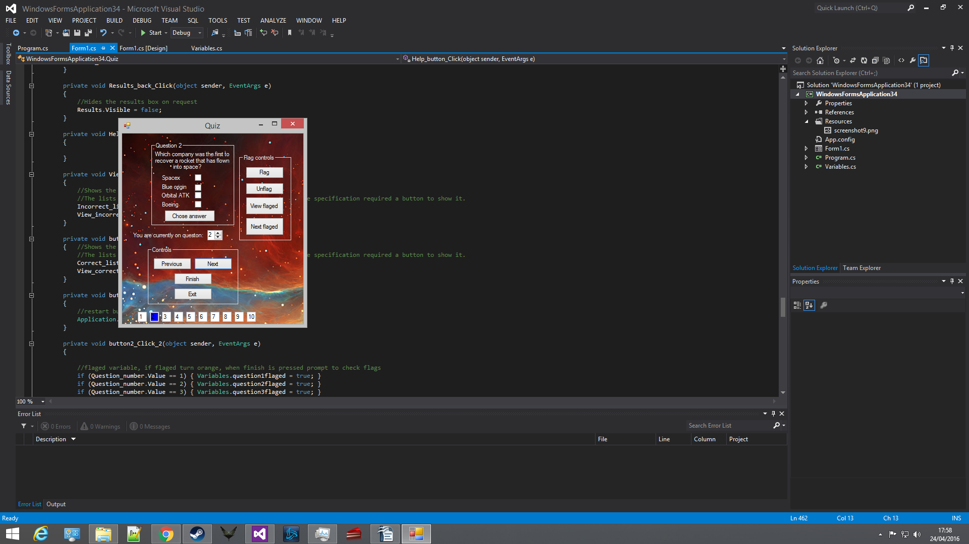
Screenshot 4
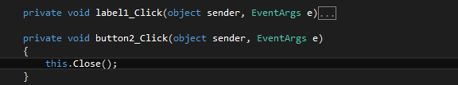
Screenshot 5
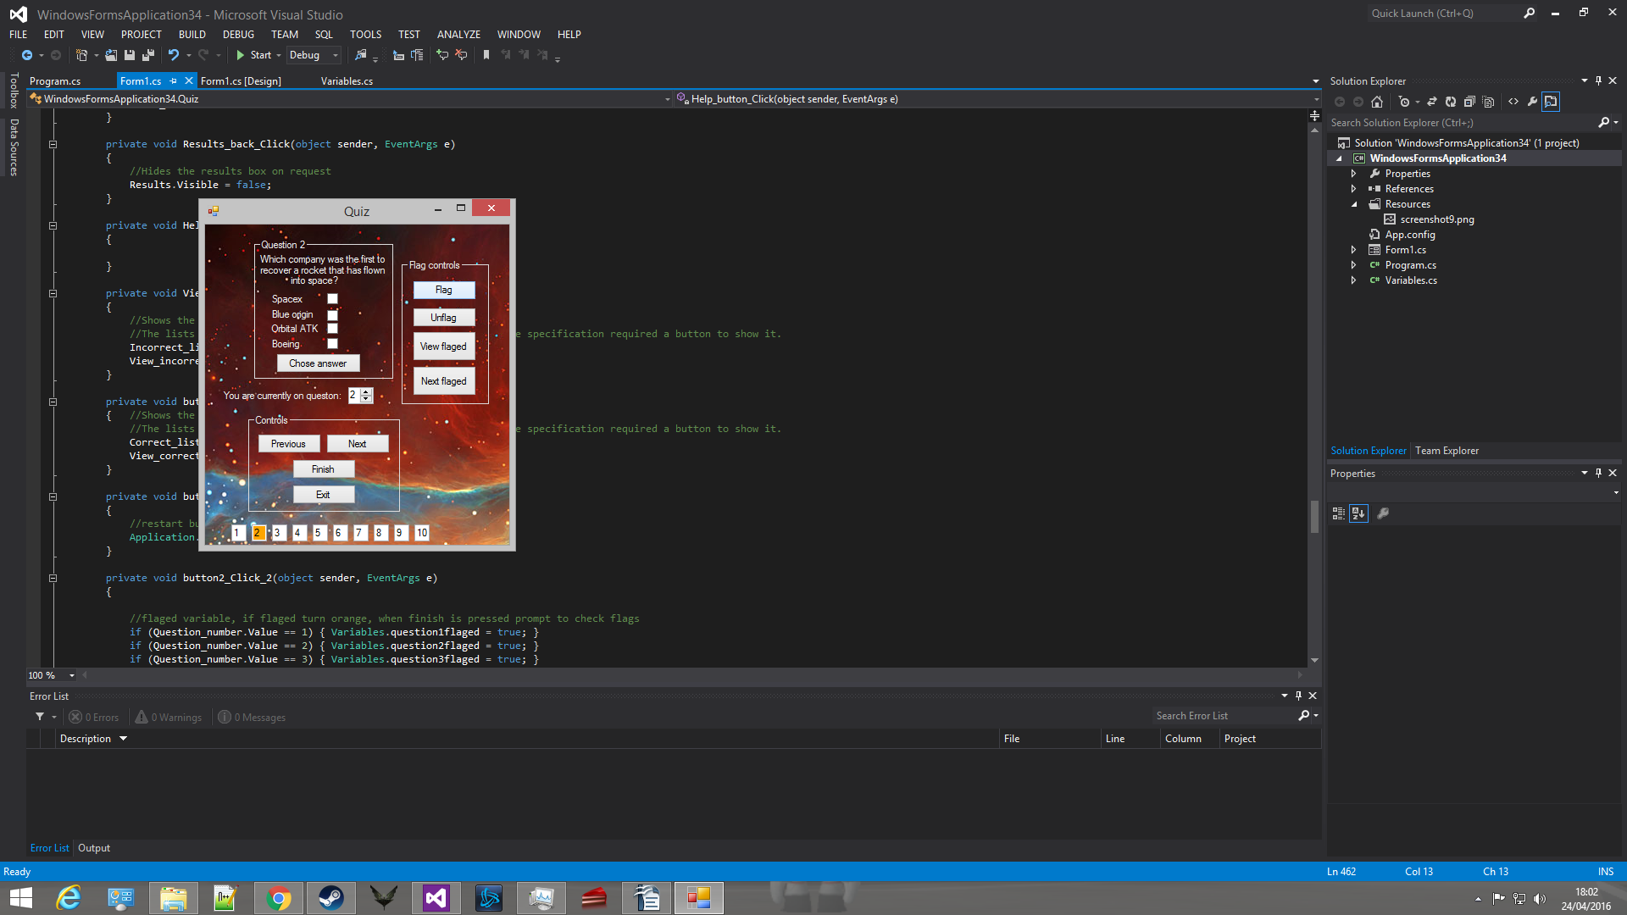
Screenshot 6
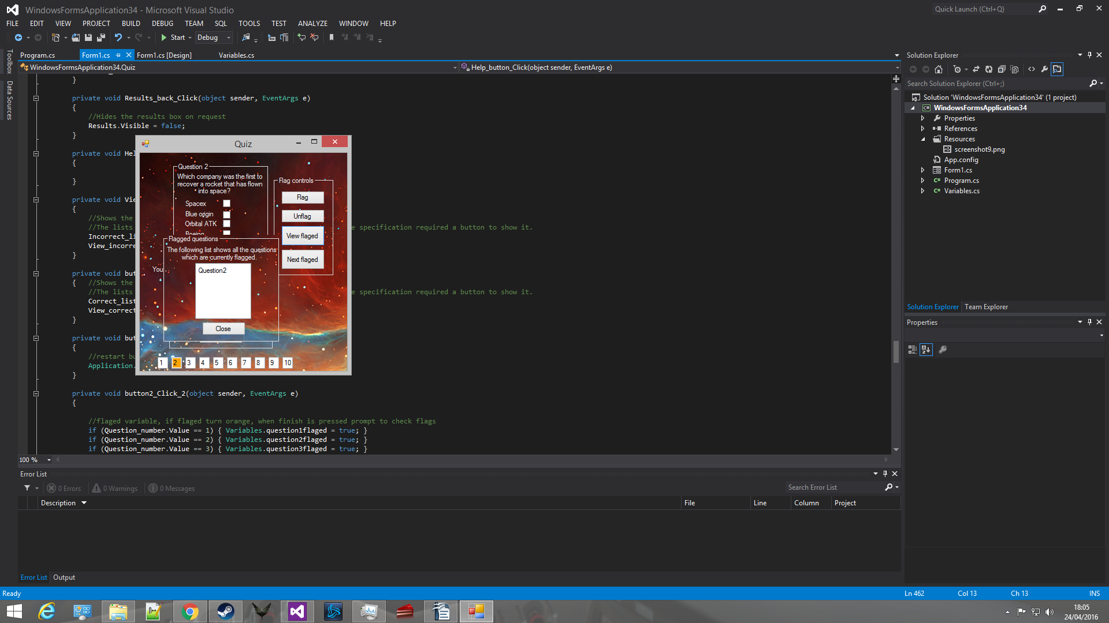

screenshot 7
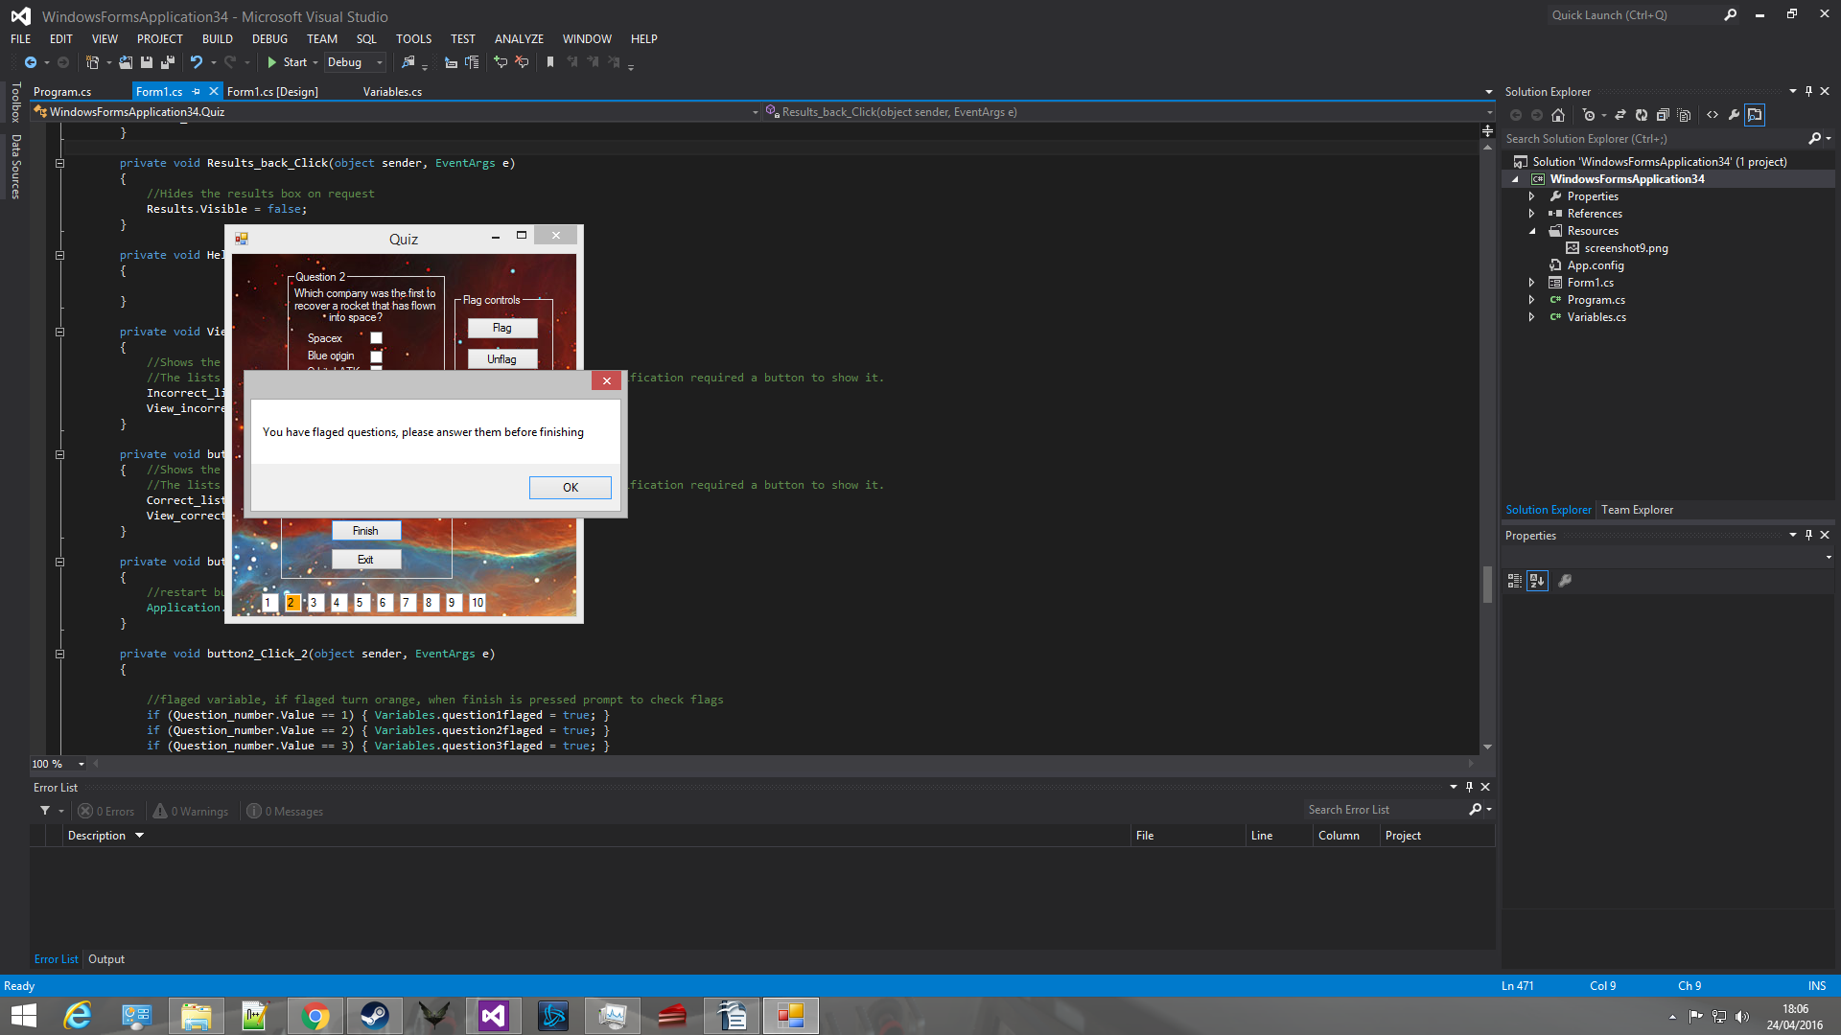
Screenshot 8
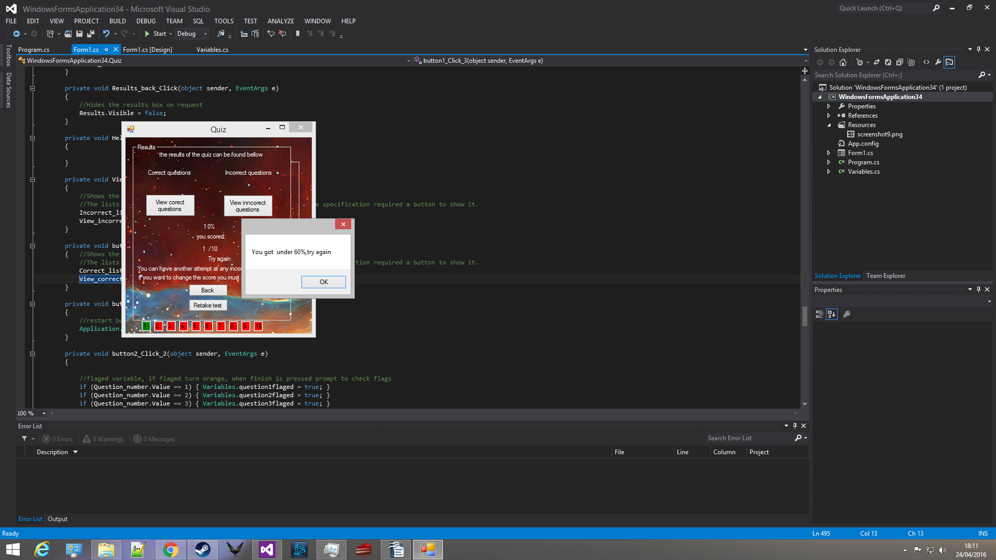
Screenshot 9
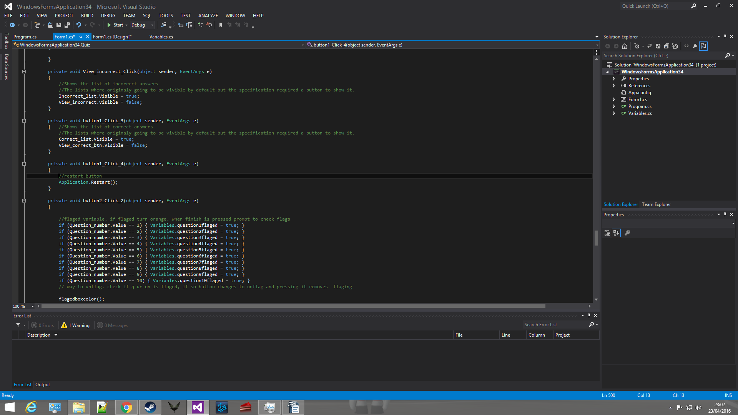
Screenshot 10
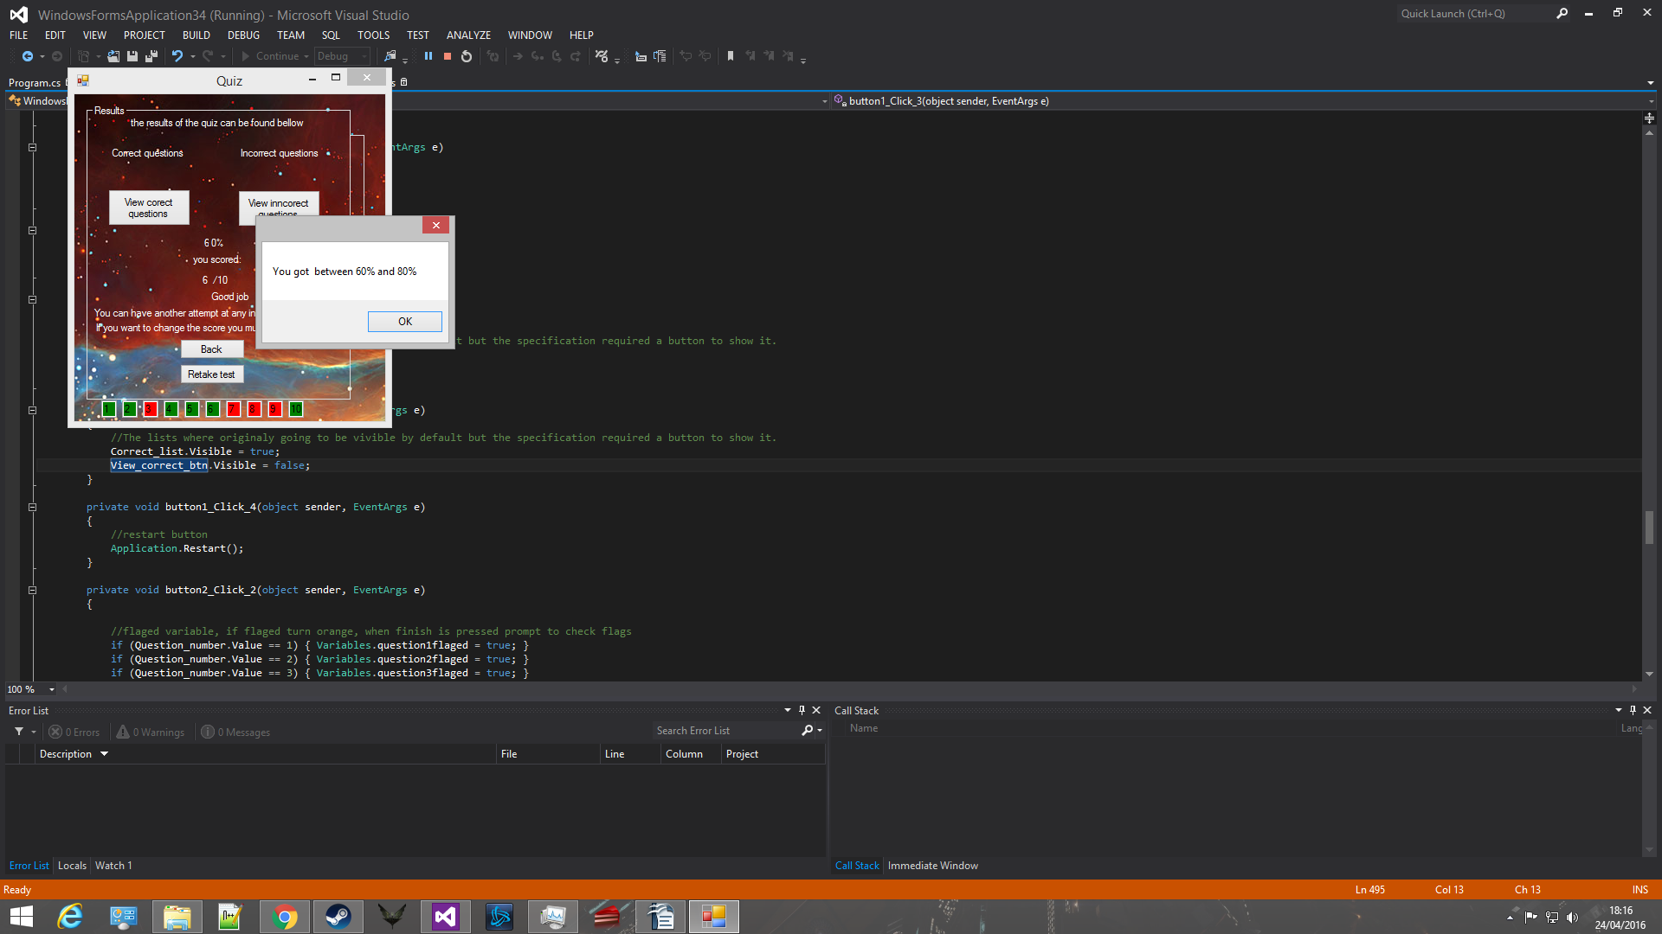
Screenshot 11
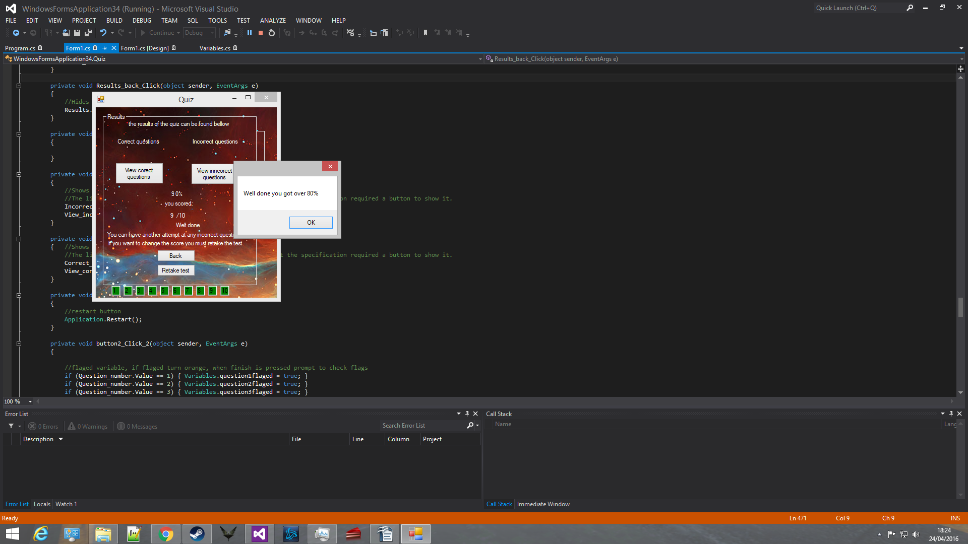
Screenshot 12
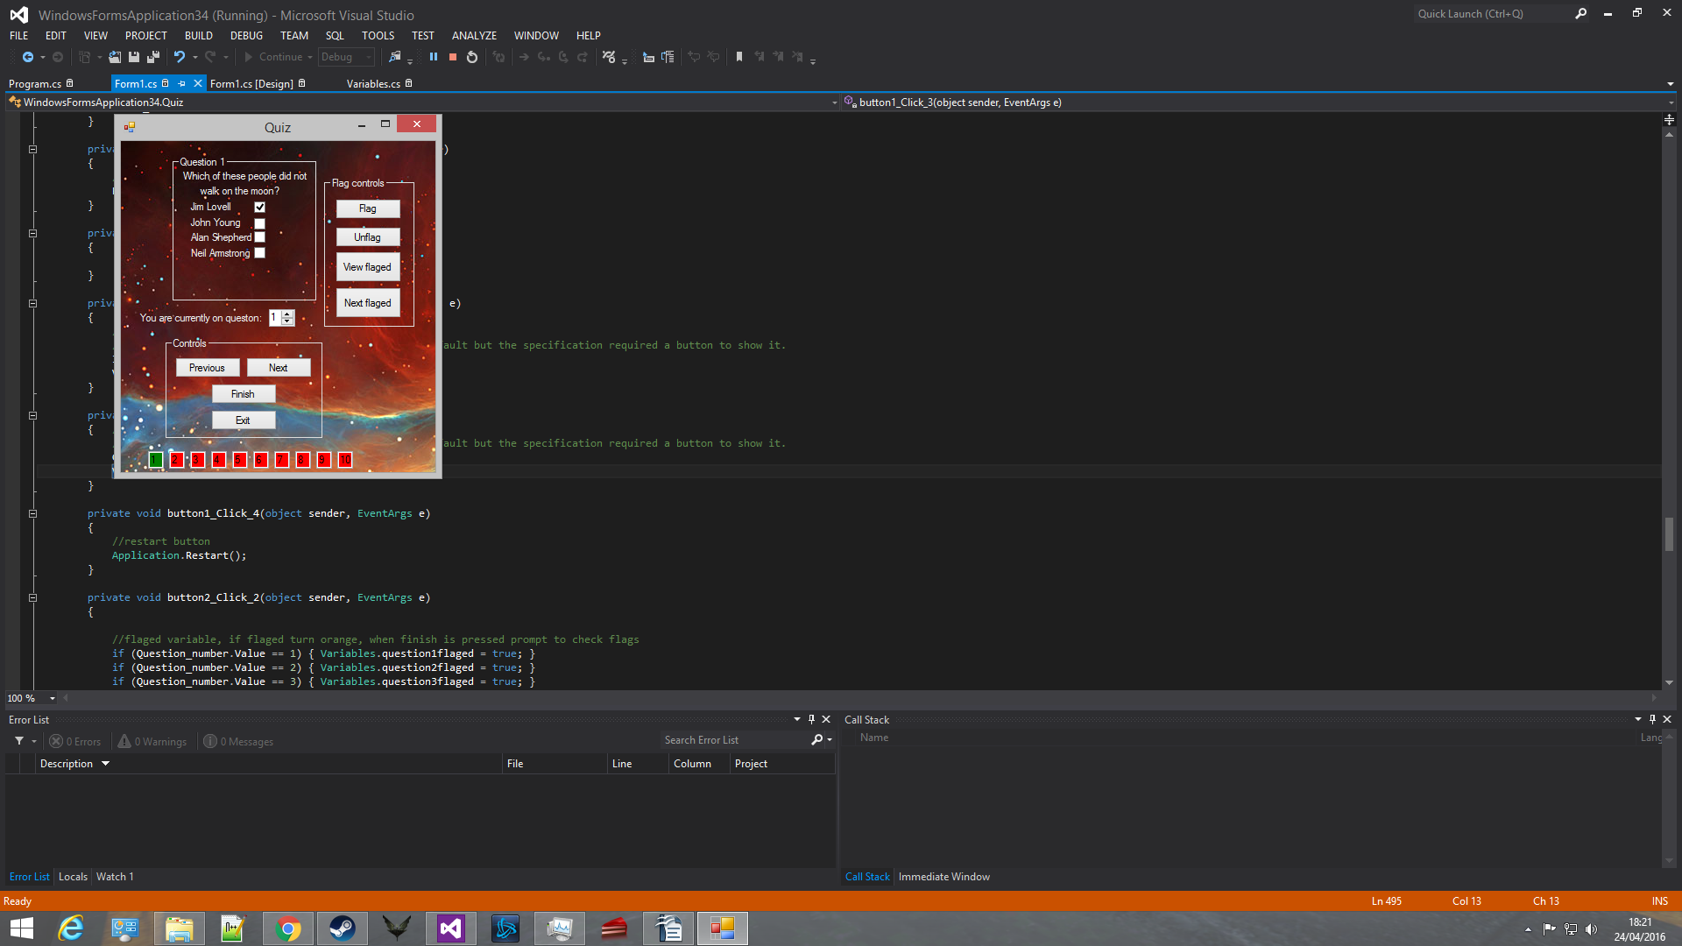
Screenshot 13
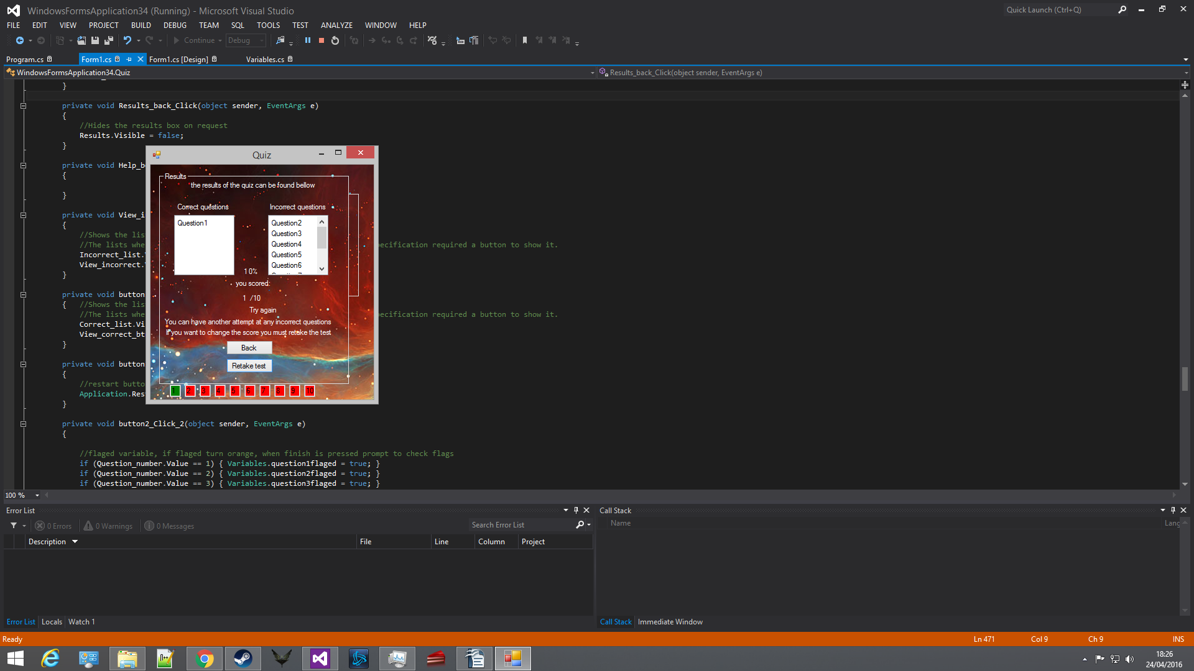
Background image:
http://www.twitrcovers.com/twitter-covers/nebula/ 24/4/2016

